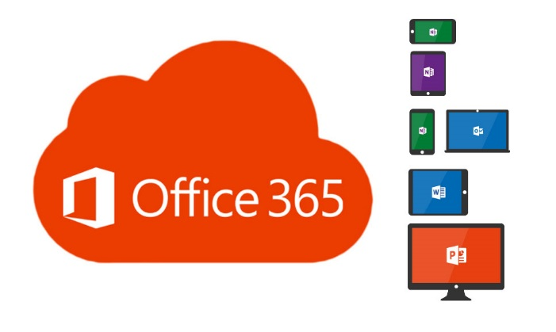**Office 365 Guide for Students**

**Student Email Addresses**

* All student Office365 logins will be their username and password they use to log in to the computers in school, followed by @thekings.staffs.sch.uk
* **For Example:   
  Student Username:** Joe-Smith / password  
  **Email Address/O365 login:** Joe-Smith@thekings.staffs.sch.uk / password

Students can log in to Office 365 using the ‘**O365 Email**’ link on their desktop or by typing ‘**Office 365**’ into Google. They will need to enter their email address first and then their password to log in.

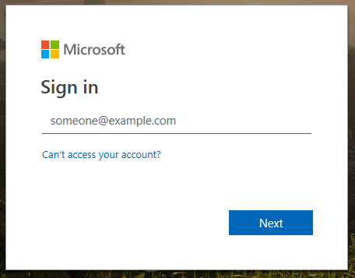

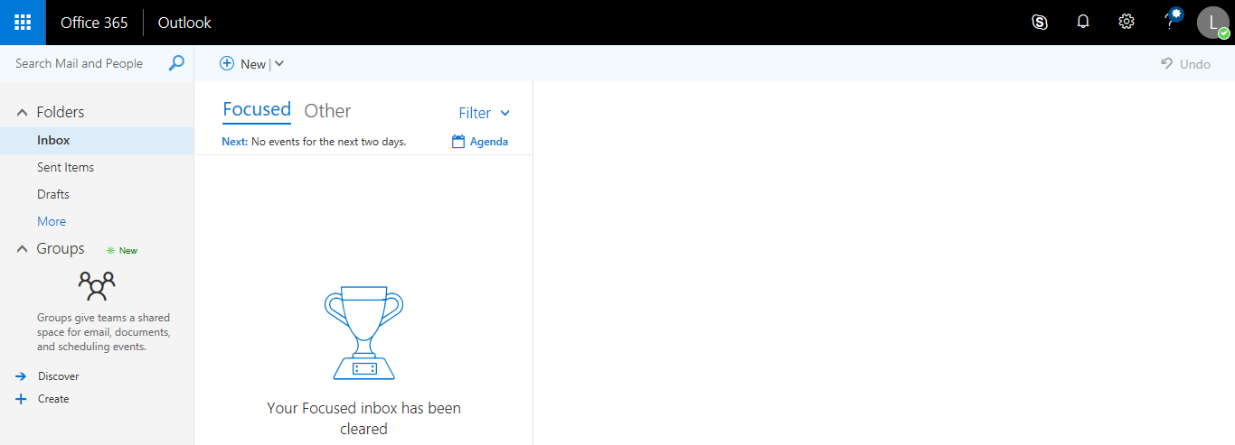

When students first log in their email will open. To access the apps they need to click the tile icon in the top left corner.

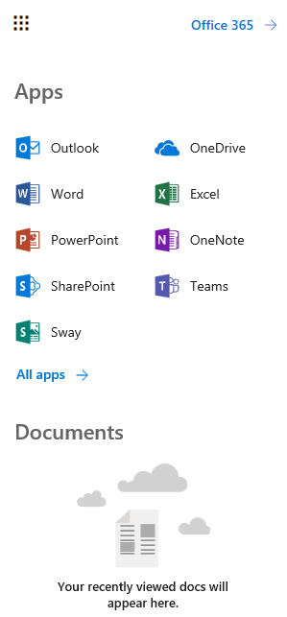

When they click the tile they will see the most commonly used apps in Office 365. They can click **All apps** to access any others they may need to use.

Apps students will most likely use:

* Outlook (Email)
* OneDrive (Cloud storage)

**OneDrive**

All students have a OneDrive account with **1024 GB** (**1Terabyte**) of data storage. Students can use this to upload, access and edit their documents and files. The files can also be shared, with their teachers or other students. All files are secure and are backed up.

**Uploading files or folders to OneDrive**

**1**

With Microsoft Edge or Google Chrome:

1. 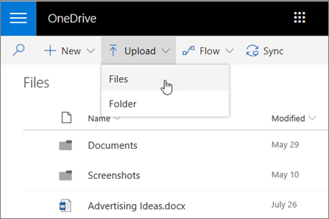Select **Upload** > **Files** or **Upload** > **Folder**.
2. Select the files or folder you want to upload.
3. Select **Open** or **Select Folder**.

With other browsers (Internet Explorer / Firefox):

* Select **Upload**, select the files you want to upload, and select **Open**.

**1**

* 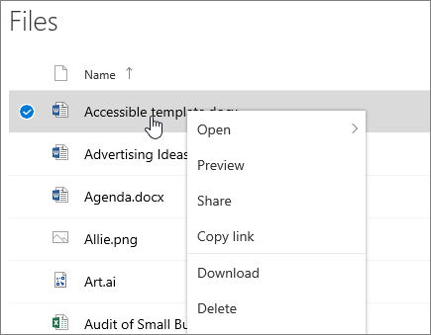If you don't see **Upload** > **Folder**, create a folder, and then upload the files to that folder.

**2**

**Managing files and folders in OneDrive**

**2**

**Select what to do with a file**

1. In OneDrive, right click the file.
2. Select a command.

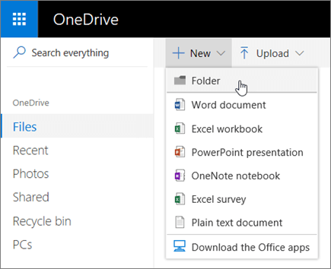

**3**

**Create a folder**

1. Select **New** > **Folder**.
2. Type a name for the folder.
3. Select **Create**.

**3**

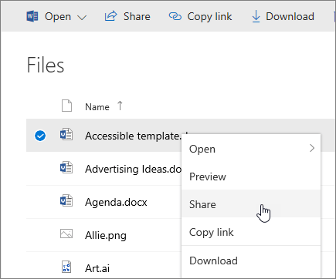**Collaboration in OneDrive**

**1**

**Share files from OneDrive**

**1**

1. Right click the file and select **Share**.

Or, select a file and select Share **Share** on the toolbar.

1. Select who you want to share with from the drop-down, or enter a name or email address.
2. Add a message (optional) and select **Send**.

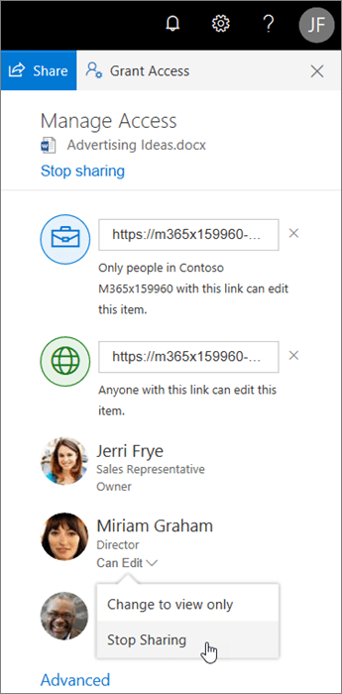

**2**

**Stop or change sharing**

If you are the file owner, or have edit permissions, you can stop or change the sharing permissions.

**2**

1. Select the file or folder you want to stop sharing.
2. Select **Information** Information in the upper-right corner to open the **Details** pane.
3. Select **Manage access** and:
   * Select the **X** next to a link to disable it.
   * Select **Can Edit** or **Can View**, and then select **Stop Sharing**.
   * Select **Can Edit** or **Can View** and then select **Change to…**.

**3**

**Copy link**

* Select a file and select Copy link **Copy link**.
* Or, right click a file and select **Copy link**.

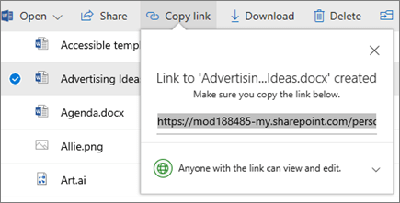

**3**