October 18th 2021
First Aid practical
As part of our robust Sixth Form programme, students at The King’s have the opportunity to take part in a wide range of enrichment activities. These are provided to ensure that we leave our school with more than just an excellent grade profile. The enrichment programme is designed to help us stand out from the crowd and become fully equipped for life after Sixth Form.
In year 12, students are given the opportunity to complete three accredited training courses which will prepare us, practically, for the work place. This half term, we have completed a Level 2 VQT in First Aid and to supplement the theoretical aspect of the course, we were taken off timetable for the day to engage with a whole host of practical activities.
Throughout the day, we learnt how to examine a casualty and how to control bleeding and trauma – “I feel so much better equipped now to address a potentially threatening situation long enough for medically trained individuals to arrive on scene.” Lena H
Other essential first aid skills included learning how to treat burns and scalds as well as assisting a choking individual. Rather than sit an exam, we were assessed throughout the day by a qualified First Aider and because all of the demonstrations we carried out were successful, every one of us were awarded with a certification which is valid for three years.
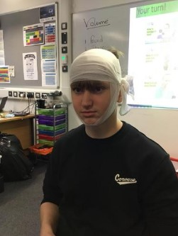
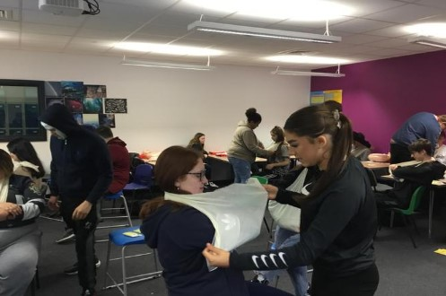
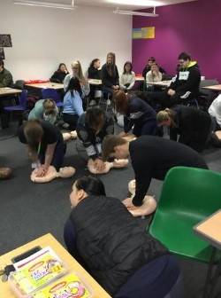
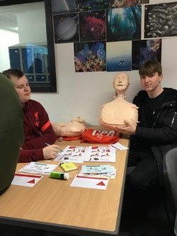
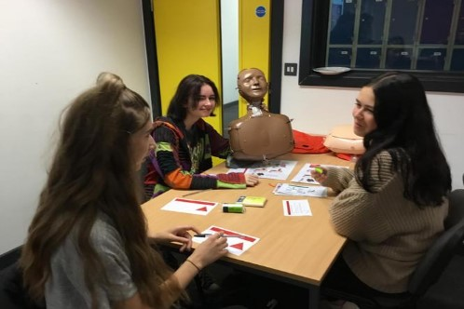
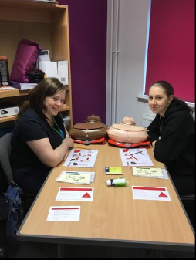
November 4th 2021
Keep The Cash
This week, year 9 and 10 students have had a wonderful opportunity to learn about money and improve their financial skills in order to make the most of their future. This was supported by a number of sixth form volunteers who, as part of their 'Giving back' programme, worked with and supported the students through the session.
We all need to earn money and then manage our finances.
This day has given all of our students the chance to learn a plethora of key, personal, financial life skills that they will be able to put to use in their day to day lives. It was a fun and interactive session which allowed students to make decisions on all sorts of important matters, in exactly the same way they will do once they leave school and start to build their own life - 'I can't believe how much numeracy can be found in our everyday lives' Oscar R Y9
The key learning takeaways for the students were:
- how to manage money
- what the impact might be in relation to the financial choices they make
- applying key learning to real world scenarios

Sixth formers played a fundamental role in the day, serving as employers and bankers. This was a brilliant opportunity for sixth formers to develop their communicative and interpersonal skills whilst simultaneously engaging and building relationships with younger members of the school
‘I’ve really enjoyed working with the year 9 students today – watching them has made me realise how important activities like these are!’ Colin K Y13
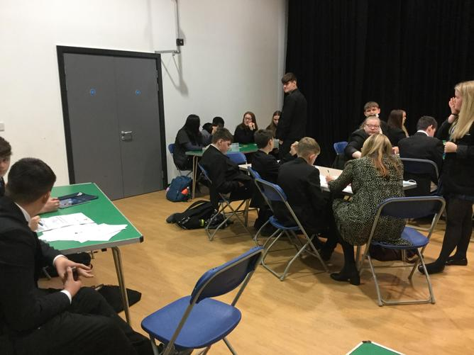
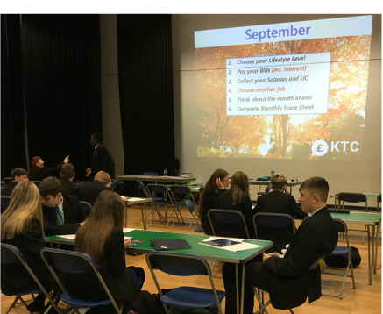

November 14th-28th 2021
National Citizen Service (NCS)
Enterprising students at The King’s Sixth Form College have raised hundreds of pounds for good causes in Stoke after taking part in the National Citizen Service (NCS).
One of the many volunteering opportunities on offer through our Enrichment Programme, the NCS is an initiative to help young people build skills for work and life, while taking on new challenges and developing new skills. Run regionally by Port Vale Foundation FC, NCS brings together young people and helps them develop greater confidence, self-awareness and responsibility. It encourages personal and social development by working on skills like leadership, teamwork and communication.
As well as engaging in a number of outdoor, team building activities including archery, raft building and canoeing, students also worked together to develop a social action project which aimed to deal with a local issue close to their hearts. This year, students were keen to support two charities, Number 11 and Swan Food Bank.
Representing the NCS in their visit to the school, Jorgie said:
“The young people have all been a pleasure to work with and are a real asset to the school. They have really come together over the week and supported one another in more ways than one!”
Head of the Sixth Form, Aimee Williams, said that the school has been actively encouraging all of their students to take part in the scheme, due to the nature of the NCS’s work:
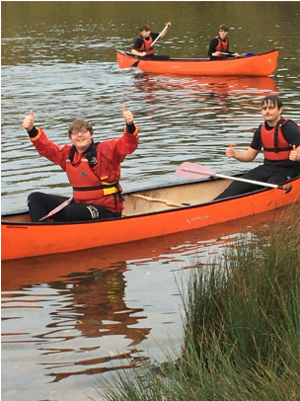
“Sixth Form in The King’s places great focus on enrichment and leadership alongside academic achievements. The National Citizen Service programme combines all of these attributes and we are delighted that our students are keen to participate in it.”
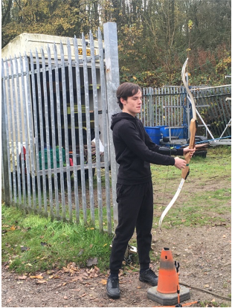
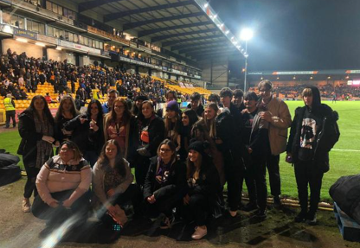

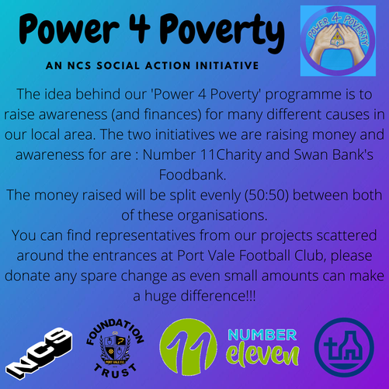
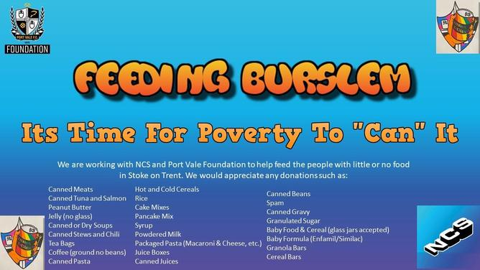

December 13th 2021
Staffordshire University
On Monday, students from year 12 and year 13 were given the chance to experience university life in Stafford.
Seminars were set up to introduce them to higher education; understand the standard fees and most importantly, get a flavour of university life.
The day involved a tour of the facilities and students taking part in a number of workshops including nursing, criminology, psychology and biomedical science.

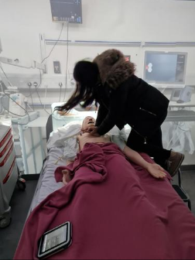
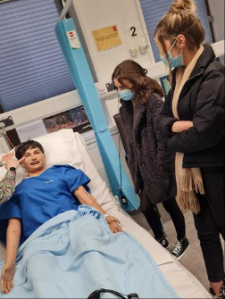
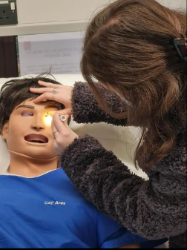

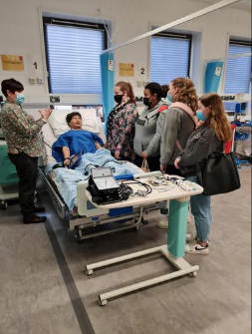
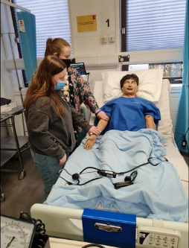
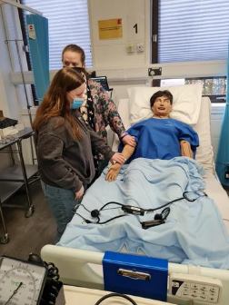
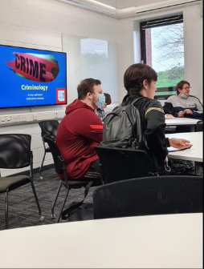
January 20th 2022

Changemakers

Now, more than ever, teamwork makes the dream work. And as the community starts to find a new kind of normal after COVID, everyone needs a little extra help, whether that’s physical, mental, emotional, online or offline.

With this in mind, a number of our sixth form students attended their first Changemakers meeting today which was hosted by our partners Port Vale. Within the meeting, the students agreed that they wanted to make a 'change' to an issue close to their hearts, food poverty.

Over the course of 12 weeks, the students will gain a better understanding of how their community works and what it needs; creating a more positive and sustainable future for everyone. Continuing the work from the NCS programme they completed in November, students have set a challenge to raise as much money as possible in order to create food hampers to 'feed Burslam'.

Already, the group have some excellent ideas and have started to plan charity events to raise funds. In order to support and educate the community, students will also be creating 'cooking on a budget' recipe cards which will nest in the hampers they provide.

WORDS FROM OUR CHANGEMAKERS
"The Changemaker Project has changed me into a new person, someone who is even more passionate about issues regarding our community. It has made me a better team-player, a better listener and a better friend"
Rachel Salt
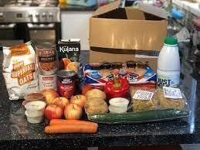

February 3rd 2022
VTQ’s
Here at The King's Sixth Form, students in Year 12 are given the opportunity to complete VTQ's in Health and Safety in the Workplace, Mental Health in the Workplace, Food Safety and First Aid. All help to prepare them, practically, for the work place and at the same time enhance their CV.
Well done to our Year 12 Students who have already completed these courses!

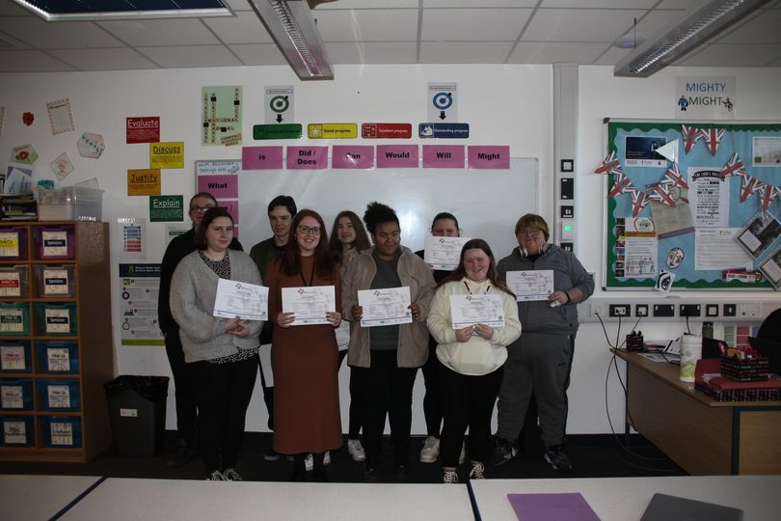

February 9th 2022
Primary Links – St Saviour’s
The Sixth Form enrichment and personal development programme is designed to help our Sixth Form students stand out from the rest of the crowd and become fully equipped for life after Sixth Form. This term as part of the programme, our Year 12 students have been able to get involved with The King’s Academy Primary Links Programme. This involves local primary schools who are given the opportunity to experience high school taster days at The King’s Academy to help with their transition to high school in the future.
These taster days help to enrich the experiences of children currently in Primary School and give them a positive outlook on high school life. At the same time by working with the local primary schools, our year 12 students have the opportunity to experience what life in the world of work is like and add valuable work experience to their CV.
Three of our students had amazing feedback from a recent primary links day with St Saviour’s Academy. Ebony Birks, Alec Henderson and Rhys Campbell all helped to support and made an outstanding impression on all teachers and supporting staff!
“They were absolutely amazing, not only did they support the session, they interacted with the students really well and even sat down and had a chat with them all at lunchtime making them feel really comfortable and part of the school. The visiting teacher was really impressed with them!”
Mrs Berrisford

February 15th 2022
“Cooking on a budget” Day
Yesterday our Year 12 Sixth Form students participated in "Cooking on a Budget" day.
Students learnt all about healthy eating and how to be economical with their ingredients and leftovers. They also researched how to plan a healthy and nutritious menu for the week with a restricted budget.
For their main course students prepared and cooked a delicious roasted vegetable lasagne using a recipe card to guide them (the cooking room smelt amazing!). For dessert again using a recipe card and their own initiative students prepared an incredible apple crumble!
Using the meals that they had prepared today and from the research they had done in the morning, students then designed some "Easy to Make" recipe cards with step by step instructions on how to prepare low budget meals. These will then be used for the NCS Changemakers "Feeding Burslem" Project.
Prior to this as part of the Sixth Forms robust enrichment program all students completed their VTQ in Food Safety.
Well done to all those involved!
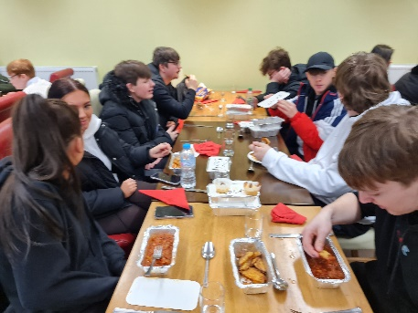
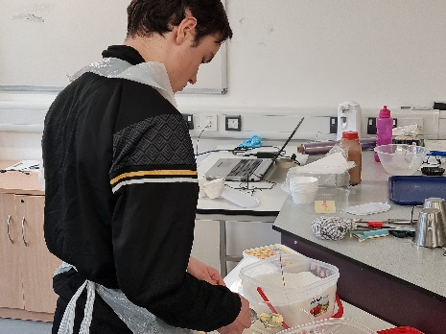
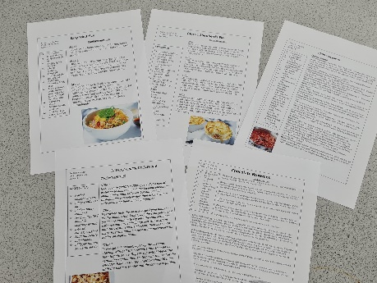
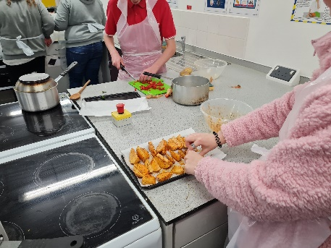
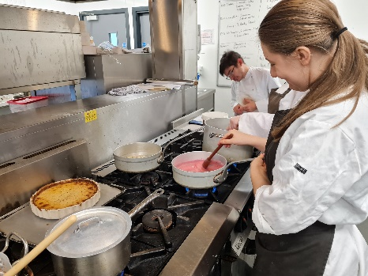
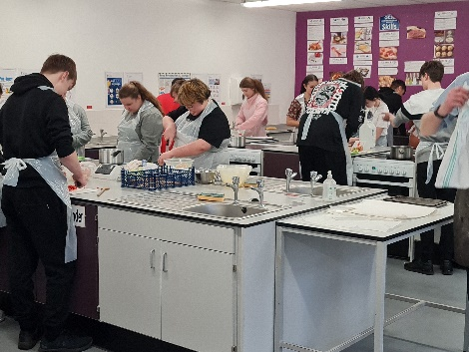
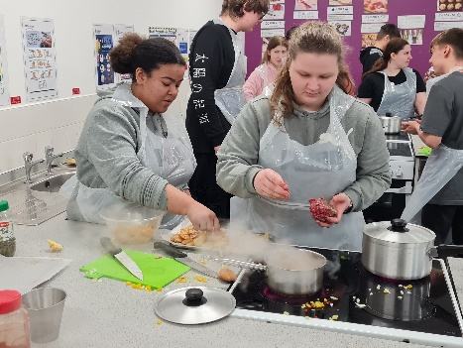
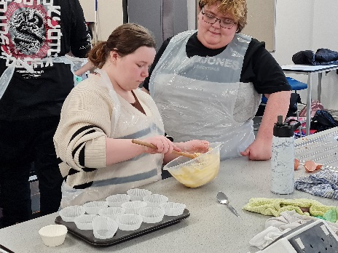
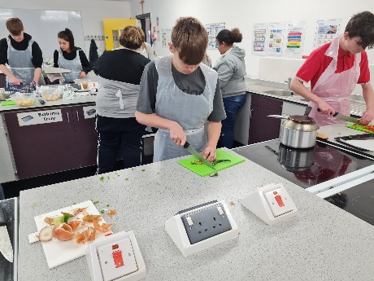
February 26th 2022
NCS Graduation
On Saturday 26th February our Year 12 Sixth Form students were invited to Vale Park to graduate from the NCS programme which they completed in the Autumn Term.
The NCS (National Citizen Service) Autumn Programme is a fantastic opportunity for our students and specifically designed for sixth form students in their first year of higher education. The programme provides a chance to gain independence, meet new people and develop essential skills for the future. Students are prepared for the world of work and university, through exciting outdoor activities, creative workshops and volunteering with local charities.
Our sixth form students had an excellent time supporting in the fan zone prior to the Port Vale Vs Stevenage match, participating in various activities to help. Before kick-off the students were then invited to the pitchside to be presented with their graduation certificates from Mrs Hinchcliffe, Jorgie (NCS Lead) and Sarah (EFL Trust). Universities and employers actively seek candidates who have taken part in the NCS programme as they will be able to demonstrate skills which are essential in the modern world, such as public speaking, teamwork and leadership.
Students then stayed to watch Port Vale go on to win the match 2-0!
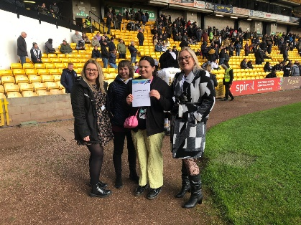
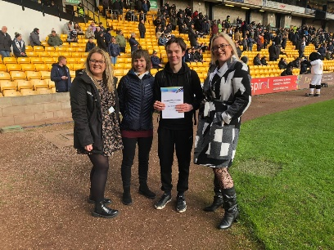
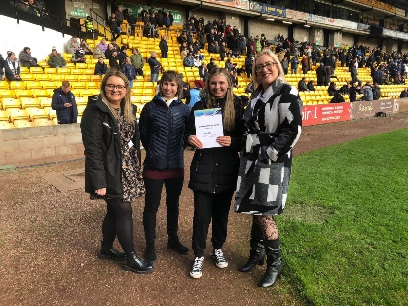
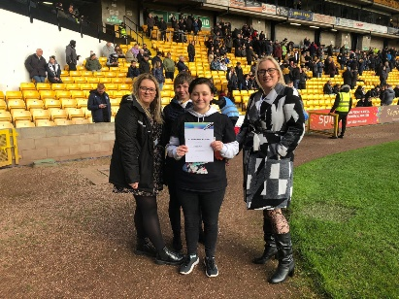
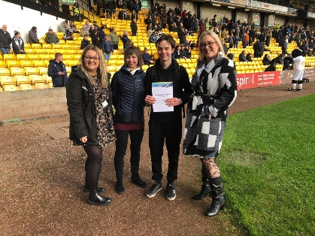
A big well done to all Sixth Form Students who got involved in NCS!
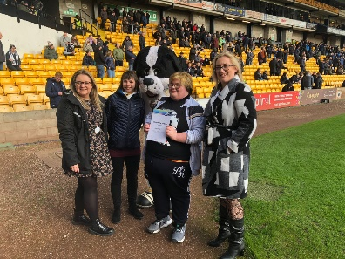
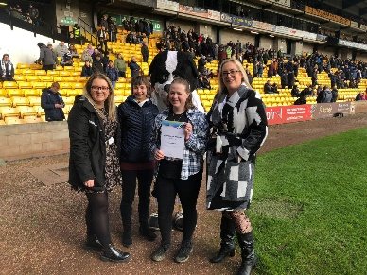
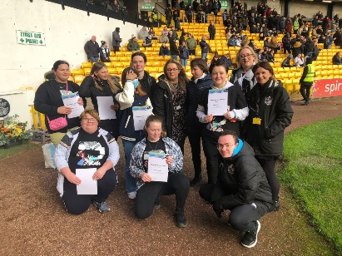
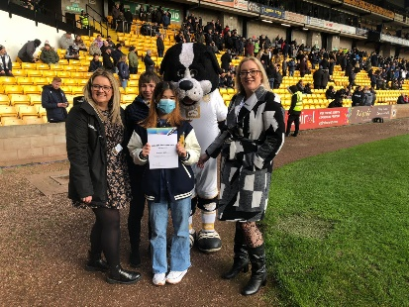
March 8th 2022
NCS Takeover Day
On Friday 4th March two of our Y12 Sixth Form Students, Ebony and Alec, who are also PVFC ambassadors, helped to support with an NCS Takeover day at Port Vale FC.
Kemball SEN School were struggling to gain work experience for their students so the team at NCS offered for them to shadow different job roles at the Port Vale grounds for the day. Ebony and Alec provided essential support to the students, helping them to apply for the job roles they were interested in, preparing for a mock interview and then effectively ‘working’ with them in that field for a few hours.
Ebony and Alec helped to support with the whole event from start to finish giving them the chance to gain independence, meet new people and to develop essential skills for the future. As well as gaining voluntary service which they can add to their CV to make them stand out from the crowd!
The whole day is just another amazing insight into the outstanding enrichment programme provided here at The Kings Sixth Form alongside the amazing partnership we have with Jorgie and the team at NCS.
“Ebony and Alec were amazing on Friday, they got involved straight away and supported the young people throughout the day with their different job roles. They should be very proud of themselves!”
Feedback provided by Jorgie Wallace – NCS Project Lead

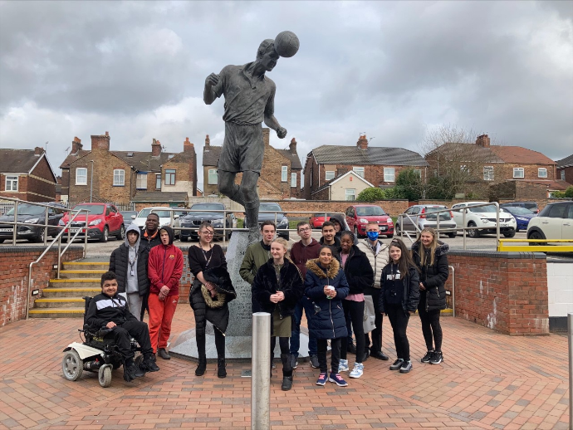

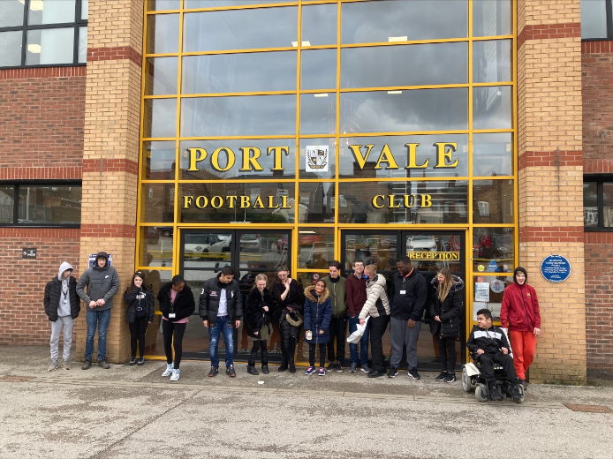
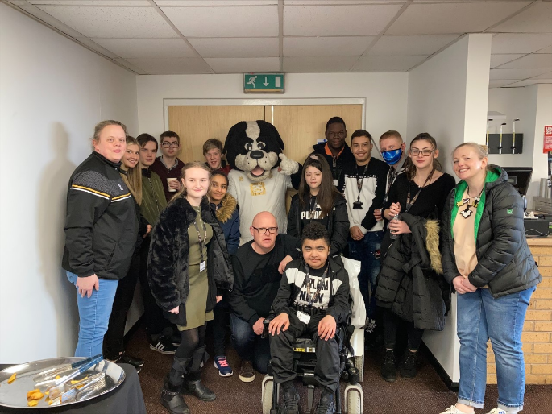

March 14th 2022
Career Ready
Today our Year 12 'Career Ready' students have taken part in a masterclass with Catherine Franklin from Eurostar Global and Caroline Emery from Career Ready.
The students have been developing their understanding of how to be successful at interviews, including how to prepare for an interview and how to carry out the job interview successfully. They discovered the different types of interviews, how to effectively research an employer in advance of the interview and how to analyse a job description.
This has been a fantastic experience for our Sixth Form students who will be undertaking interviews over the next two years for university, apprenticeships, part time and full-time employment!
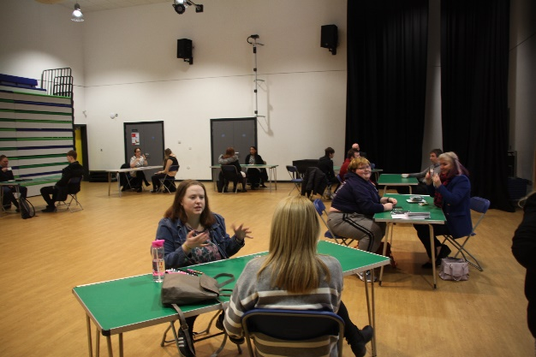

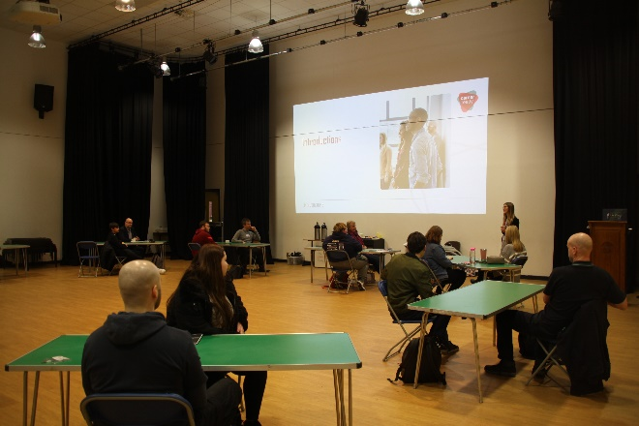

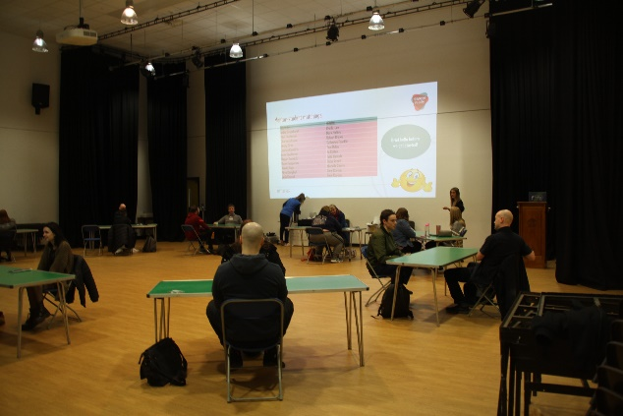

May 10th 2022
Driving Enrichment
As part of our enrichment programme, starting in September, we will be working in partnership with Max’s Masterclass Driving School to help support our students with their driving skills.
Using our rewards system, we will be offering students the chance to exchange their points to go towards funding their driving theory test, driving lessons and Max’s revision help.
To give students a taster we had Kevin Wilcox, a road safety officer, from Staffordshire County Council visit this week to deliver some road safety education.
https://www.helpingnewdrivers.co.uk/
https://maxsmasterclass.com/
https://passtestquickerstoke.theorytestpro.co.uk/stud.../new
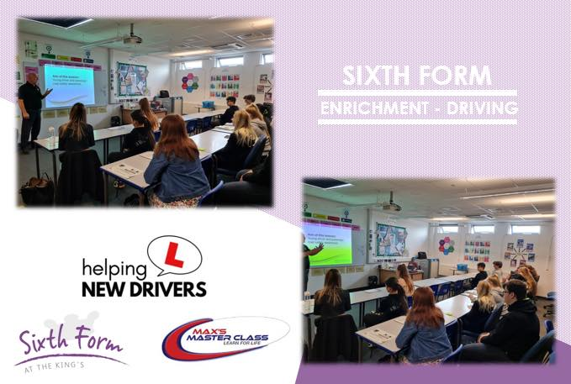

May 12th 2022
Mental Health Awareness Week
For Mental Health Awareness Week this year, the theme is raising awareness of the impact of loneliness on our mental health and the practical steps we can take to address it.
One in four of us feel lonely some or all of the time. There’s no single cause and there’s no one solution. After all, we’re all different! ​But the longer we feel lonely, the more we are at risk of mental health problems. Some people are also at higher risk of feeling lonely than others.
https://youtu.be/XCnJ8s69LlU
This term as part of our enrichment programme within the Sixth Form we are taking a focus on Mental Health. It’s always important to take care of your physical, mental, and emotional health but with exams approaching it’s easy for students to become overwhelmed. Students will be undertaking a Level 2 VTQ in Mental Health in the Workplace throughout the course of this term. On Monday 20th June we also have the Maccas Project visiting the Sixth Form to deliver an Emotional Resilience workshop. The Maccas Project is part of North Staffs Mind and is specifically aimed at supporting young people’s mental health in the North Staffs area.
Alongside all of this, on Thursday (12.05.22) some of our Sixth Form students, Charlotte, Megan, and Connor, did an excellent job raising funds and awareness for Young Minds by dressing as Super Mario characters and selling mental health awareness ribbons within the Academy – all proceeds will go to Young Minds. They also promoted our Academy safeguarding team so that students are aware where they can access help when they need it.
Well done, Charlotte, Megan, and Connor!
www.kooth.com – get help, advice & support with anything that’s causing you stress, hardship or embarrassment
www.visyon.org.uk – Cheshire charity, based in Congleton, dedicated to improving the health, in particular the mental health, of young people.
www.youngminds.org.uk – promotes the emotional wellbeing and mental health of young people.
www.samaritans.org.uk – helpline number 08457 909090
www.supportline.org.uk Helpline no 01708 765200 emotional support & info on exam stress"
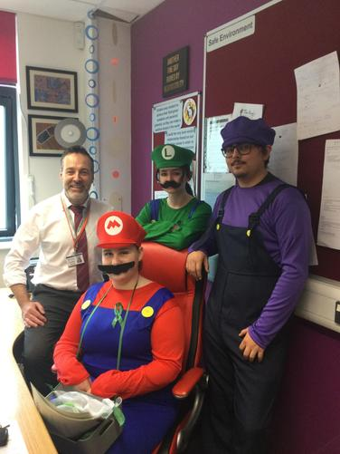

June 6th 2022
4FIIT Gym
This week some of our Sixth Formers who are studying BTEC Sport spent a fantastic day at 4FITT gym in Newcastle with James and Mark, the owners, and Personal trainers of 4FITT.
They spent time talking through the role of a personal trainer, what client consultations look like, the purpose of them and the information gathering process required to set up a successful program for a client.
Students then went through some fitness tests that would usually be used pre-program to get an idea of baseline fitness which would then be repeated at the end to measure success. Pupils also got to try out several various body weight exercises, free weight exercises and cardio machines. Completing the 500m row in the fastest time possible was definitely their favourite, with Josh achieving 500m in 1.59minutes.
Well done, Josh!
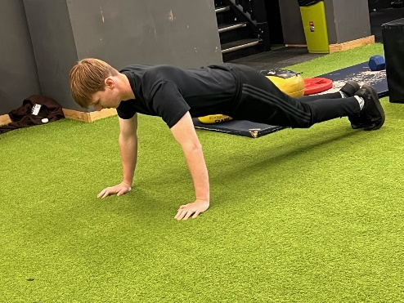
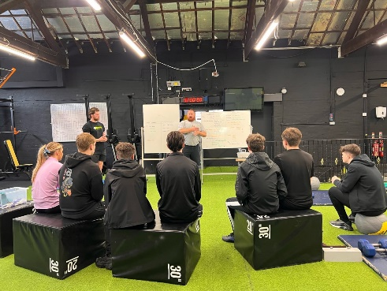
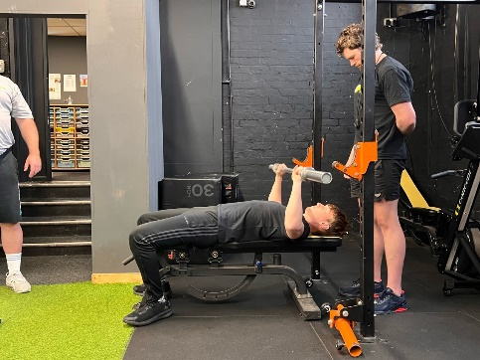

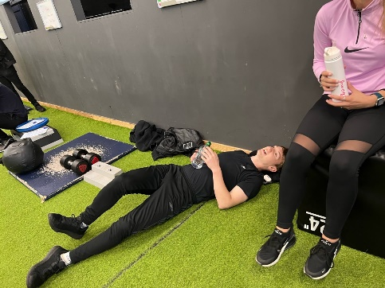

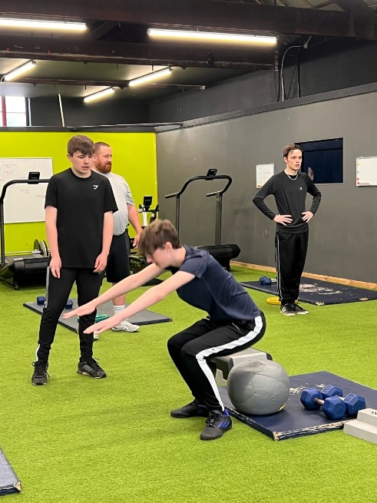
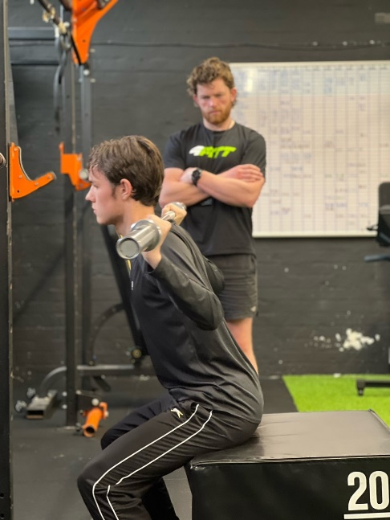

June 8th 2022
NCS
This week (Wednesday 8th June) our Head Boy and Girl, Alec and Ebony, who are also PVFC ambassadors, went to Vale Park to support with the NCS Graduation for Kemball SEN School. Here they gave speeches to the students about the NCS and how it has had an amazing impact on them.
This follows on from Friday 4th March when they both helped to support with an NCS Takeover day for Kemball SEN School.
"Alec and Ebony were an amazing support again today at the graduation, they were both exceptional when they gave their speeches about the NCS!" Jorgie Wallace - NCS Project Lead
After the event they got to take some pictures with the trophy!
