**Meaningful Homework Spring 2– WAGOLL**

**Task:** You have been scouted for a trial at a local sports team but firstly they would like to see you demonstrating your skills and applying them to competitive situations. They have asked for you to provide video footage (15 minutes) of you demonstrating your skills (3 different skills) within isolated practices. They would then like to see you applying your skills and techniques within competitive practices. This will then provide you with effective practice time in preparation for your trial.

**Success criteria:**

I have provided video footage which provides evidence of me competing in 3 isolated practices

I have provided video footage which provides evidence of me competing in competitive practices

**Guidance:**

Use drills from practical lessons to demonstrate your skills in isolated practices

Utilise your out of school teams to collect isolated drills and competitive situation evidence

**My sport: Football**

**Drill 1: Control and short passing**

*Here you should attach a video of you participating in one isolated drill for your chosen sport. Below is a screenshot of a previous example*

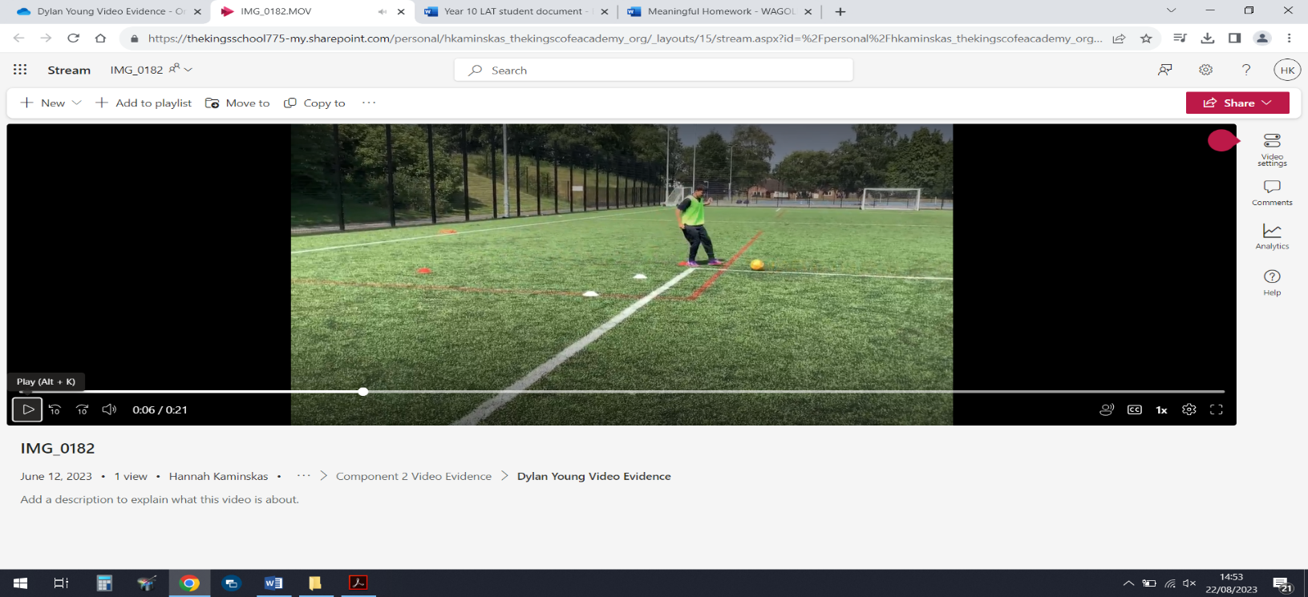

**Drill 2: Shooting**

*Here you should attach a video of you participating in one isolated drill for your chosen sport. Below is a screenshot of a previous example*

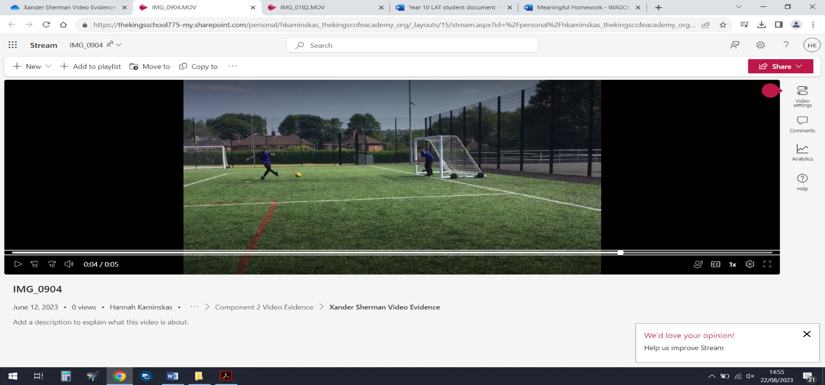

**Drill 3: Dribbling**

*Here you should attach a video of you participating in one isolated drill for your chosen sport. Below is a screenshot of a previous example*

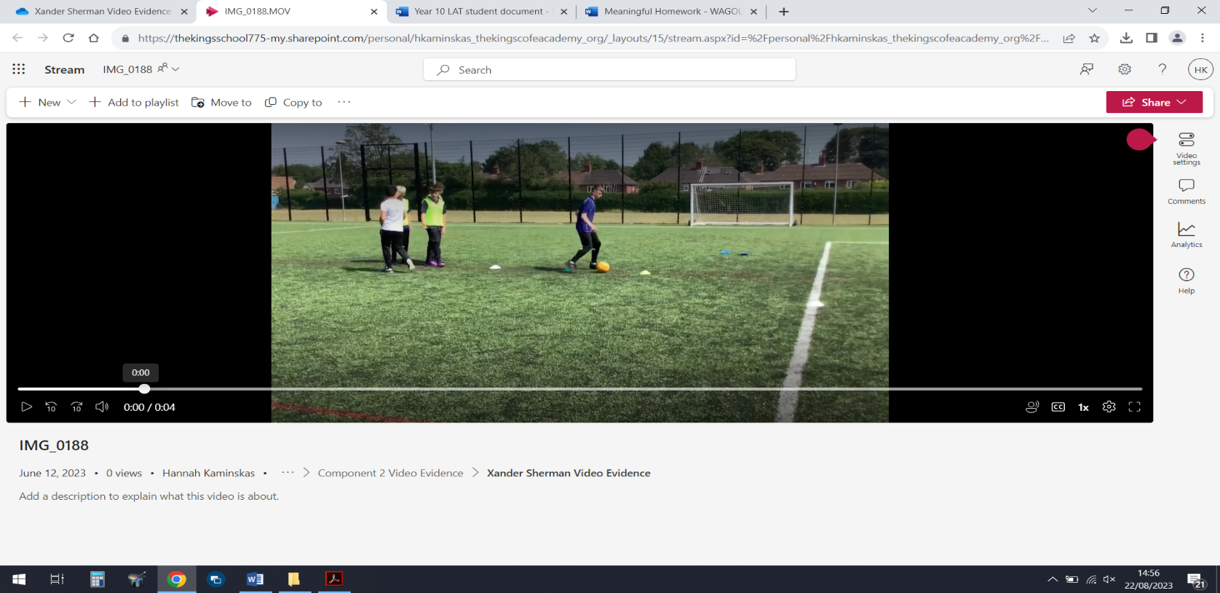

**Application to Competition:**

*Here you should attach a video of you participating in a competitive game for your chosen sport. Below is a screenshot of a previous example*

